BIT 4107 – Mobile Application Development
ENHANCED PROFESSIONAL STUDENT LOGBOOK
Student Name: _____Emmanueli Muriuki_________________________
Admission Number: ______Bit/2024/61120________________________
School/Faculty: _________Computing And informatics_____________________
Programme: _____________Bachelors of Science in Information Technology_________________

Academic Year: ______2026________________________
Semester: _____May-August_________________________
Lecturer: ______Michael Nyoro________________________
Phone Number: __0708789116____________________________

Instructions
This logbook is used to document weekly learning activities, practical exercises, skills acquired, challenges encountered, solutions applied, and reflections. Students should complete all sections every week.
Each week to follow remarks in week 1 section.

Autogenerated Table of content

Week 1: Introduction to Mobile Application Development
Thika Varsity Mobile Application created using Kotlin

Practical Activities Undertaken
only screenshots needed and labeling
Screenshots/Evidence Attached (Yes/No)

Tools/Software Used
Android studio
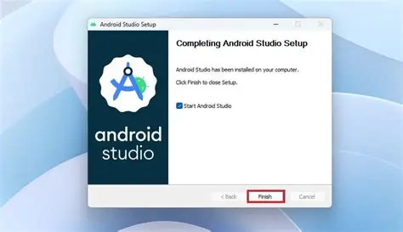

Supabase
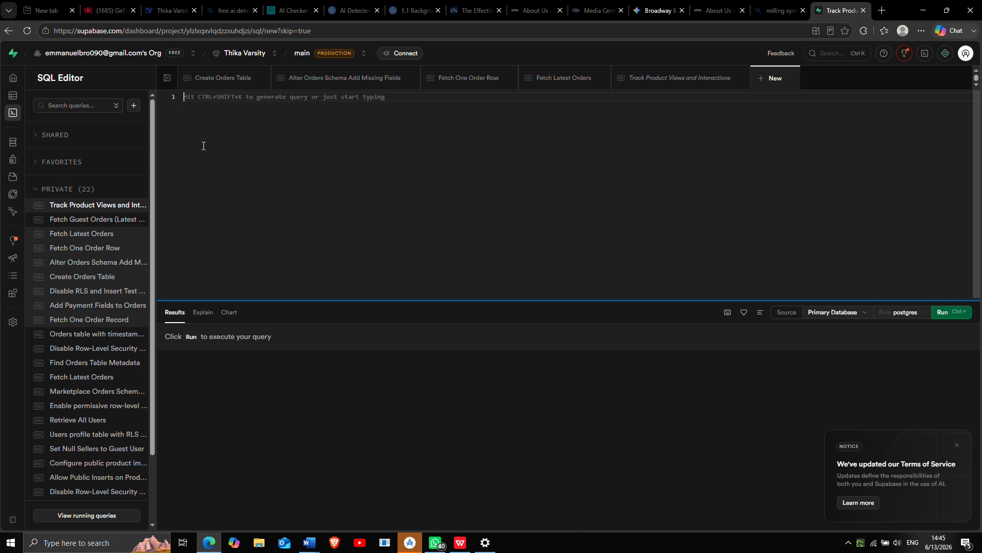

Personal Reflection
The project challenged me in integrating complex features including M-Pesa payments, AI-powered recommendations, and a pin-drop navigation system. I overcame obstacles with Firebase auth, Supabase RLS policies, and even state management in Compose. Each challenge improved my debugging skills and deepened my understanding of modern Android development in this AI generation.

Week 2: Mobile Development Environment
Emulator running hello world


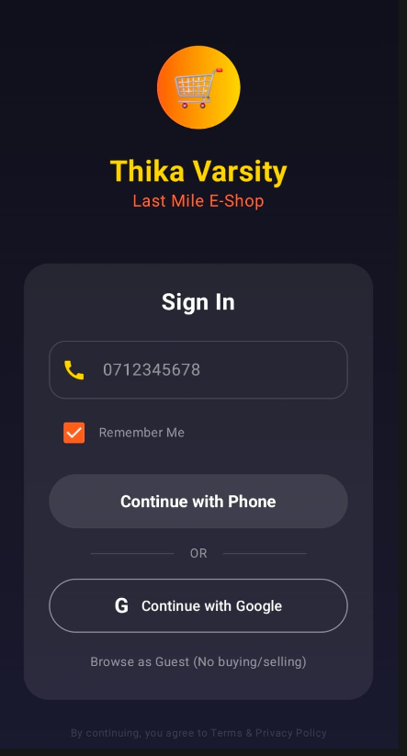
Figure 1Simple login

Week 3: User Interface Design

Figma Designs
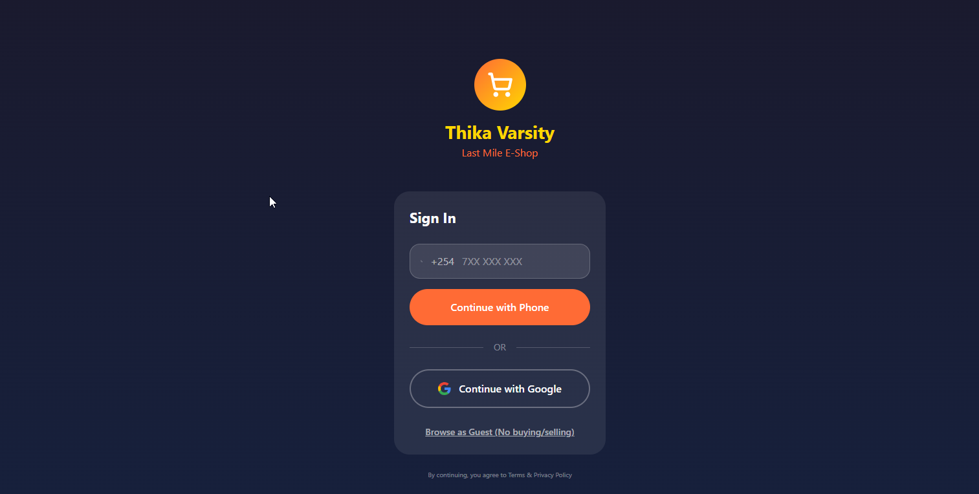
Figure 2 Login Screen
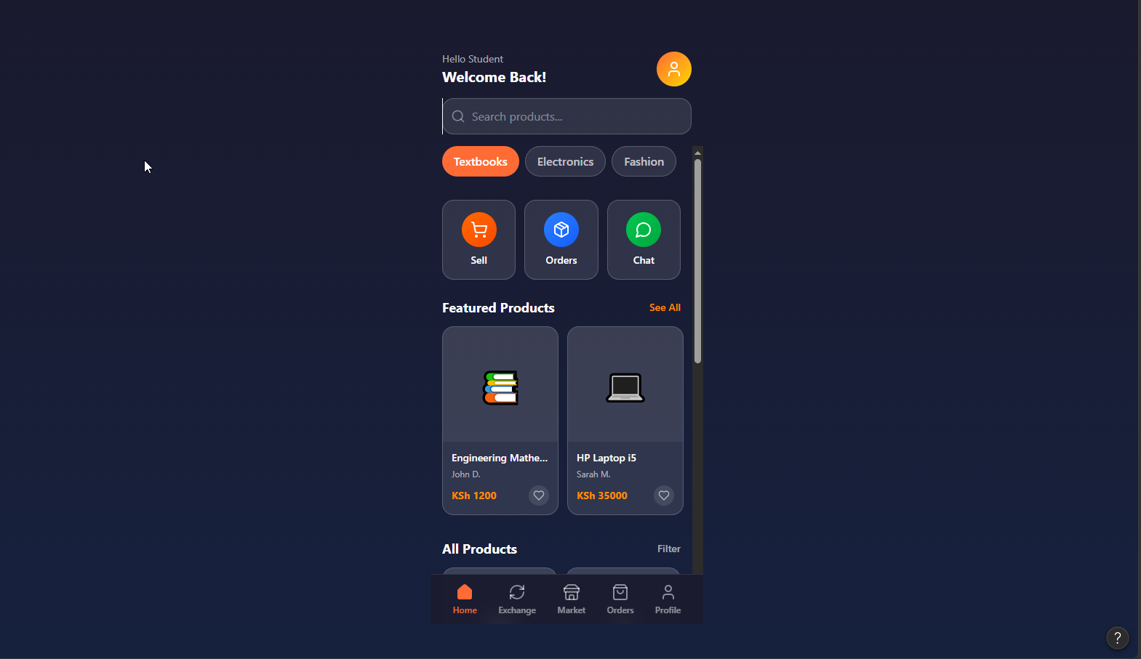
Figure 3 Home Screen
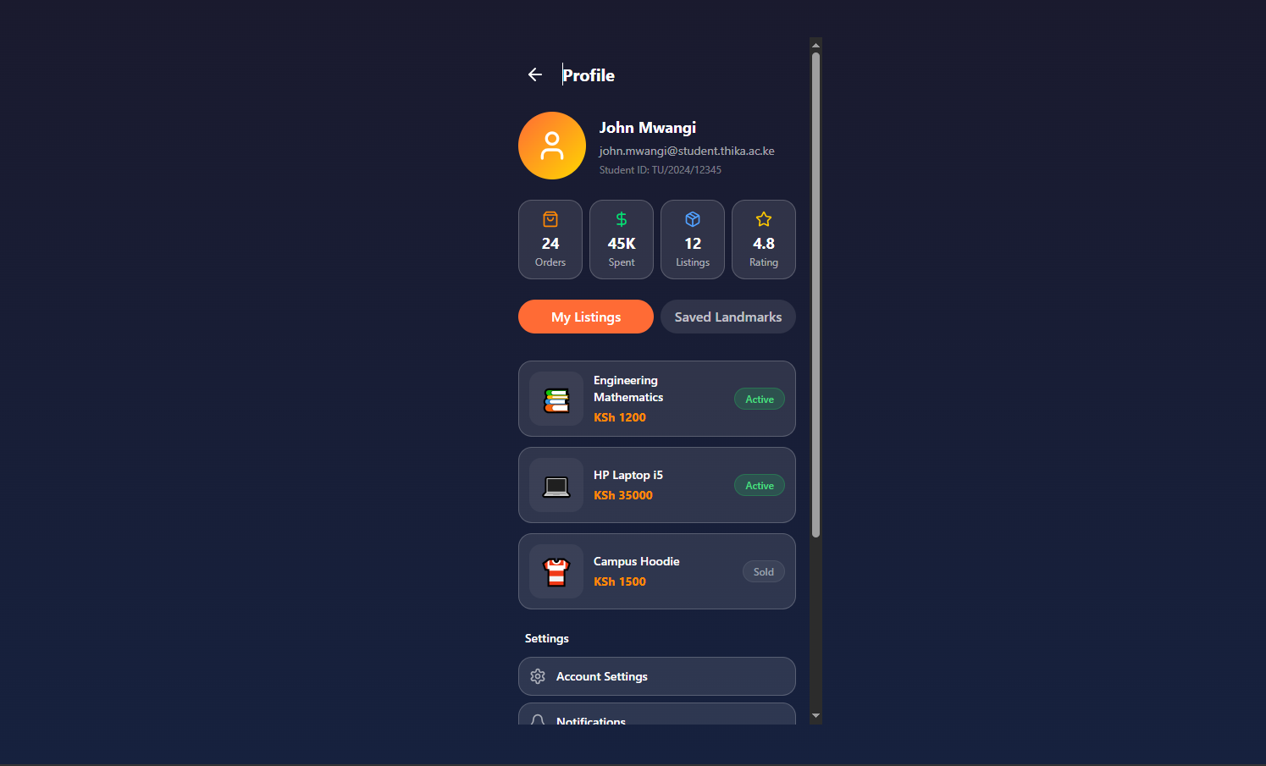
Figure 4 Profile Screen

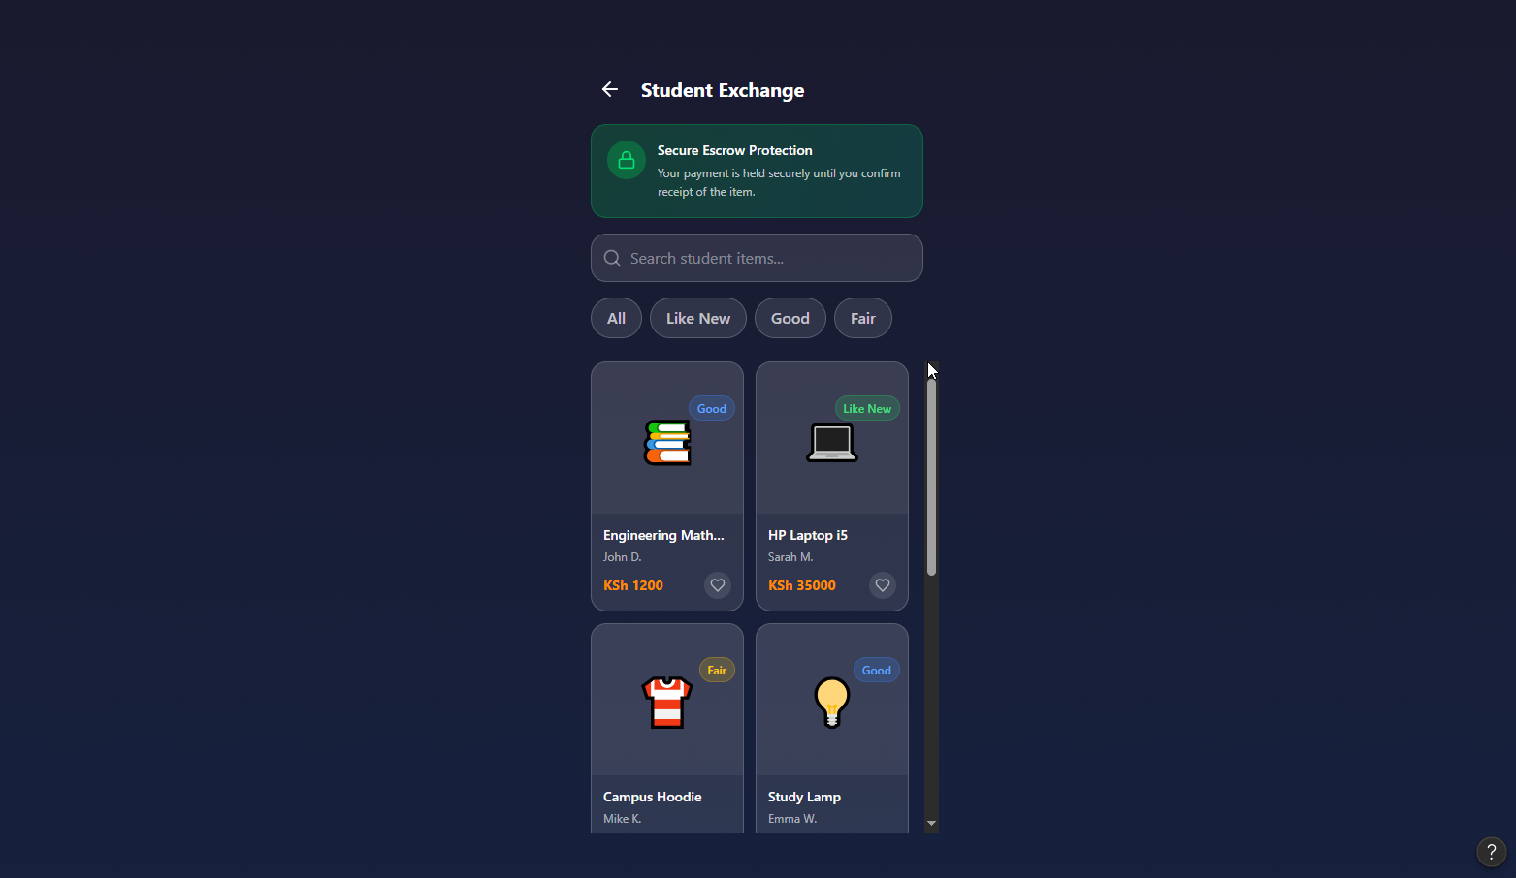
Figure 5 Student Exchange for second hand
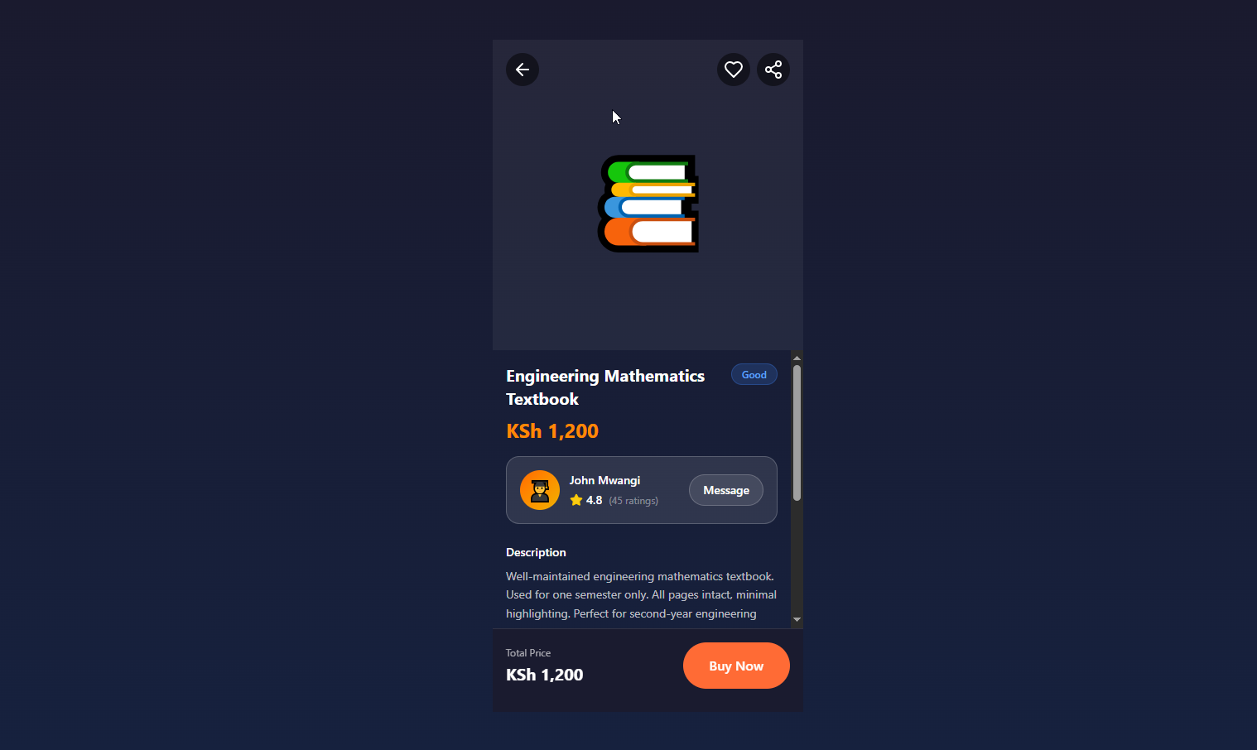
Figure 6 Product Details

Week 4: Event Handling and User Interaction
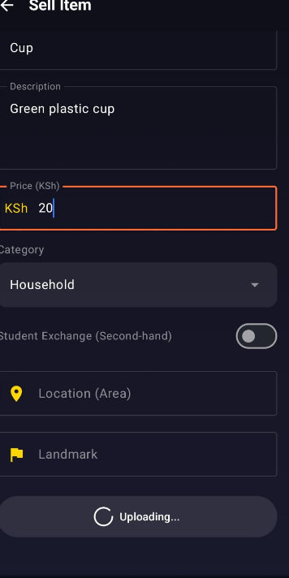
Figure 7 User interacting with system using Text field and Button

Week 5: Data Management
Preference datastore for simple rememberMe
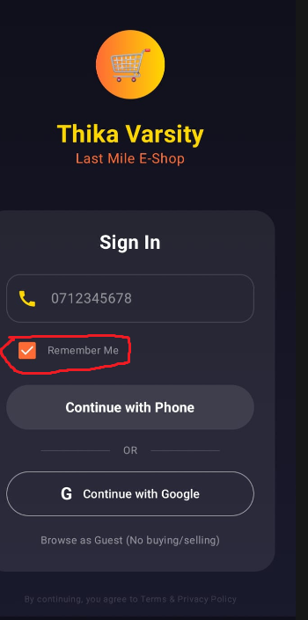

Supabase for cloud storage

Week 6: Networking and APIs

Internet permission
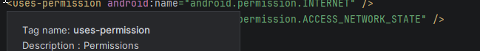
Internet was required to enable database connection , map api and mpesa apis which were used for api
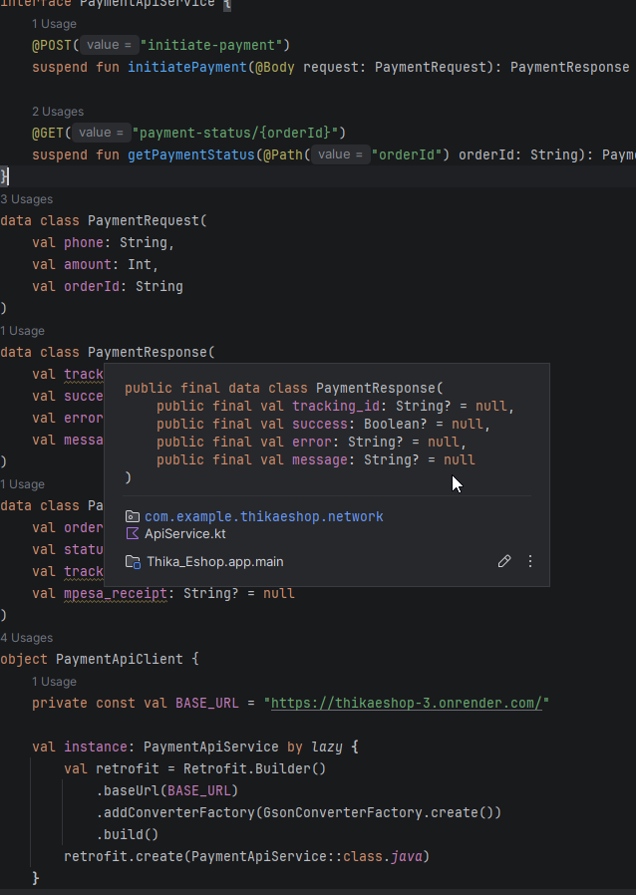

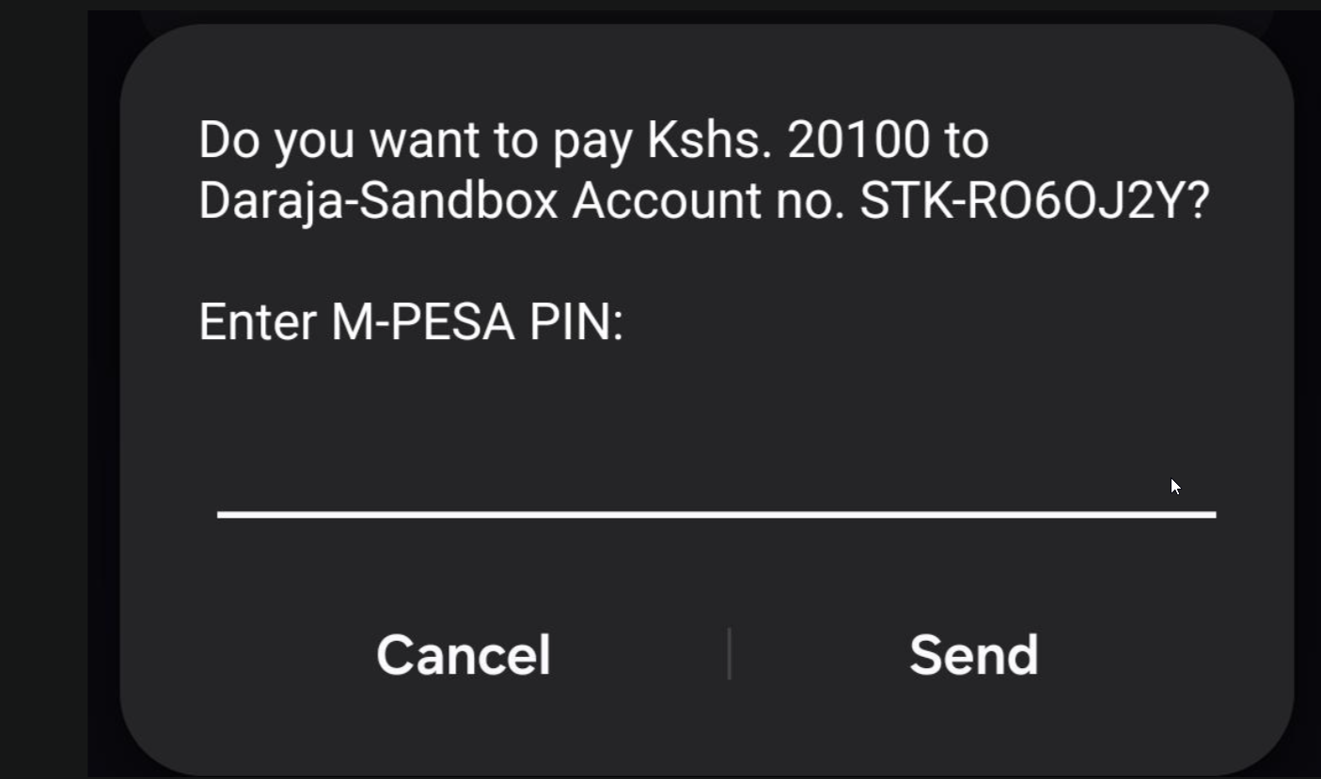
Figure 8 Mpesa Stk from Daraja Api
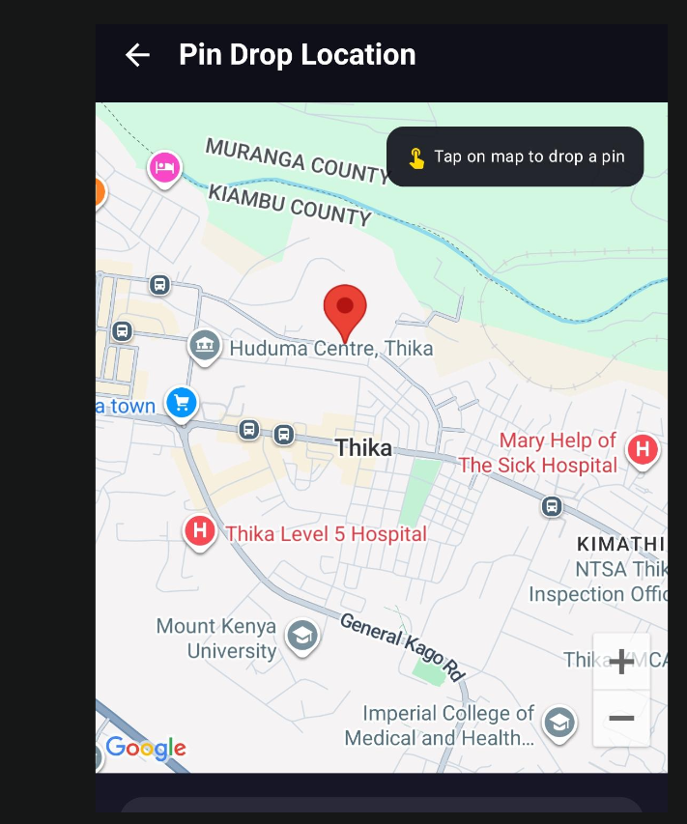
Figure 9 Google map using Google Map api

Week 7: Application Architecture

Same as week 1

Week 8: Project Planning

Week 9: Device Features and Sensors

Same as week 1

Week 10: Notifications and Background Services

Same as week 1

Week 11: Mobile Security

Same as week 1

Week 12: Testing and Debugging

Same as week 1

Week 13: Application Deployment

Same as week 1

Week 14: Final Project Presentation

Same as week 1

Semester Project Tracking

Project Title

Project Objectives

Project Requirements

Development Milestones

Testing Results

Lessons Learned

Future Improvements

End of Semester Reflection

Summary of Skills Acquired

Most Interesting Topic

Major Challenges Faced

How Challenges Were Overcome

Professional Growth Achieved

Overall Course Experience

Final Approval
Student Name: __________________________
Student Signature: ______________________
Date: _________________________________
Lecturer Name: _________________________
Lecturer Remarks: _____________________
Date: _________________________________

